**Developer Name- Kumari Soni**

**Project Name- Scientific Calculator**

**Language Used- Java (using awt and swing)**

**Output:**

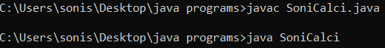

**Sample Outputs:**

1. Calculator in OFF mode

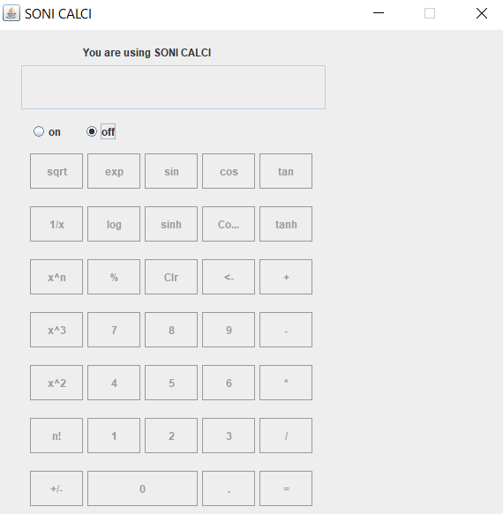

1. Add

Enter first number

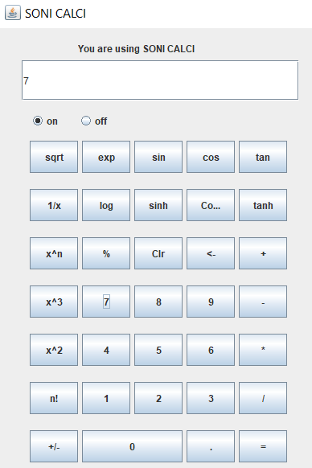

Now, press ‘+’ and enter the second number

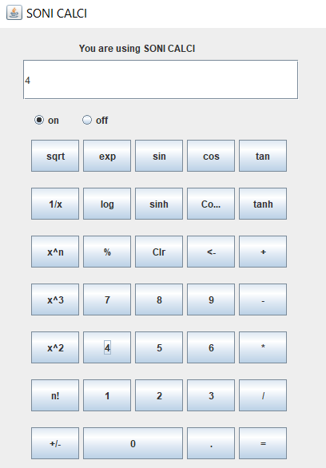

For the answer, press ‘=’

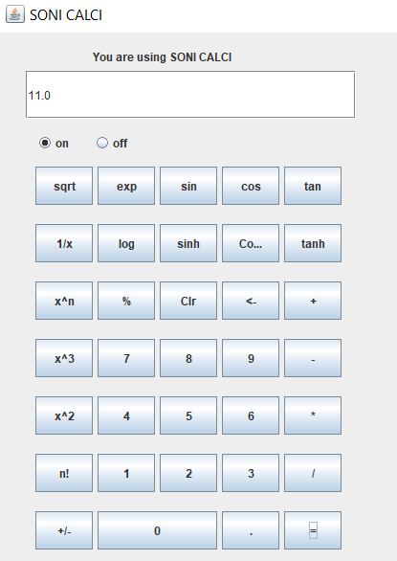

1. Sqrt

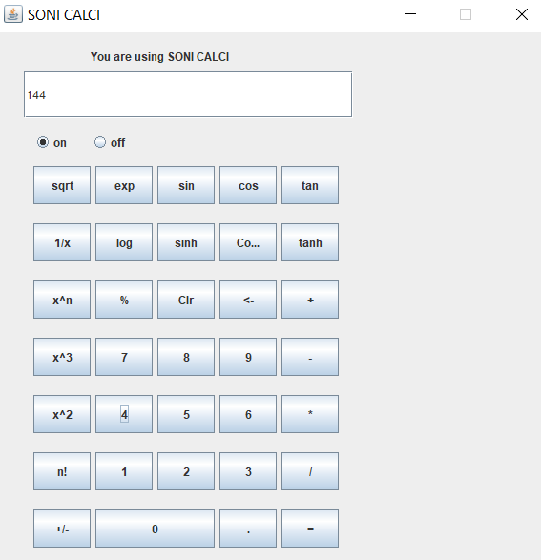

Press ‘sqrt’ for the output

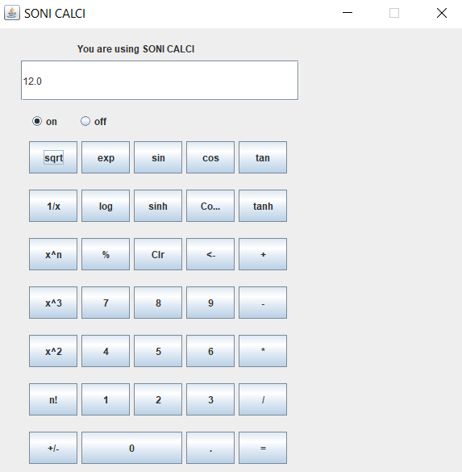

1. Exp

Enter the number x in e^x

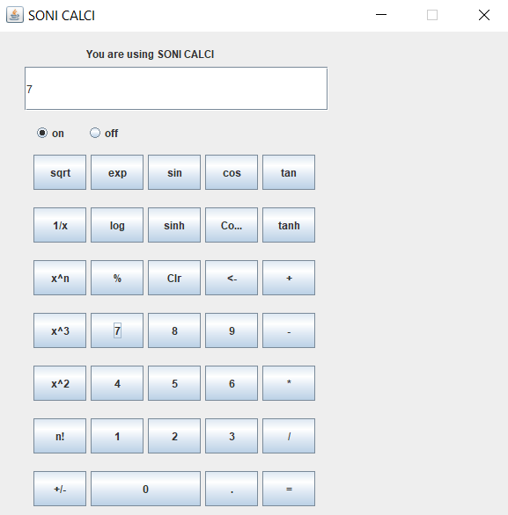

Press exp for the output

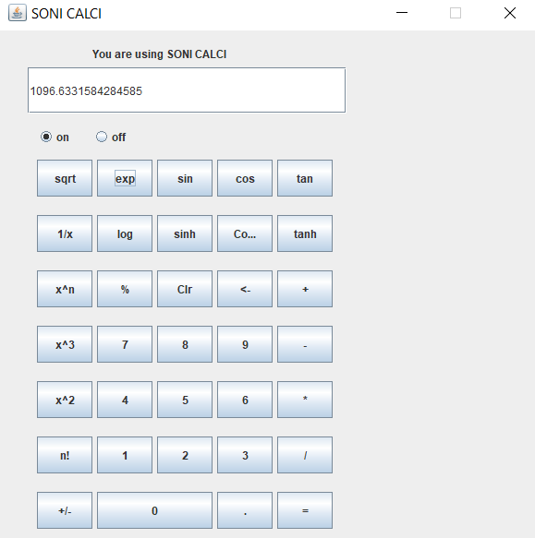

1. sin

Enter the value in radian

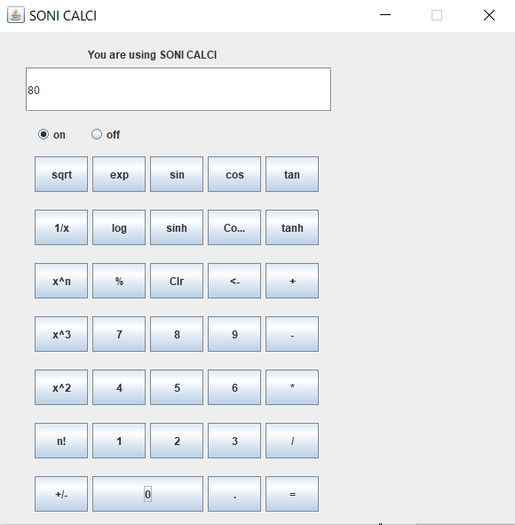

Press ‘sin’ button for output

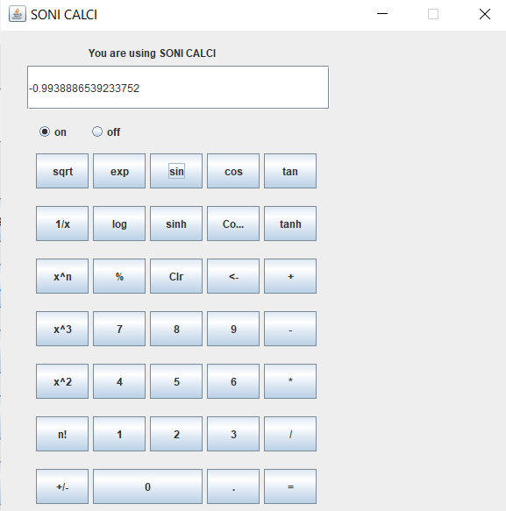

Similarly, all other buttons work and the output can be taken as required.